|  |
| --- |
| PROJECT WORK  HALDIRAM’S |

HERE IS SOME INFORMATION ABOUT HALDIRAM’S

Welcome to the home of all your favourite haldiram products. Haldiram sweets, namkeen, bhujia, soan papdii, snacks & more. Free Shipping on orders.

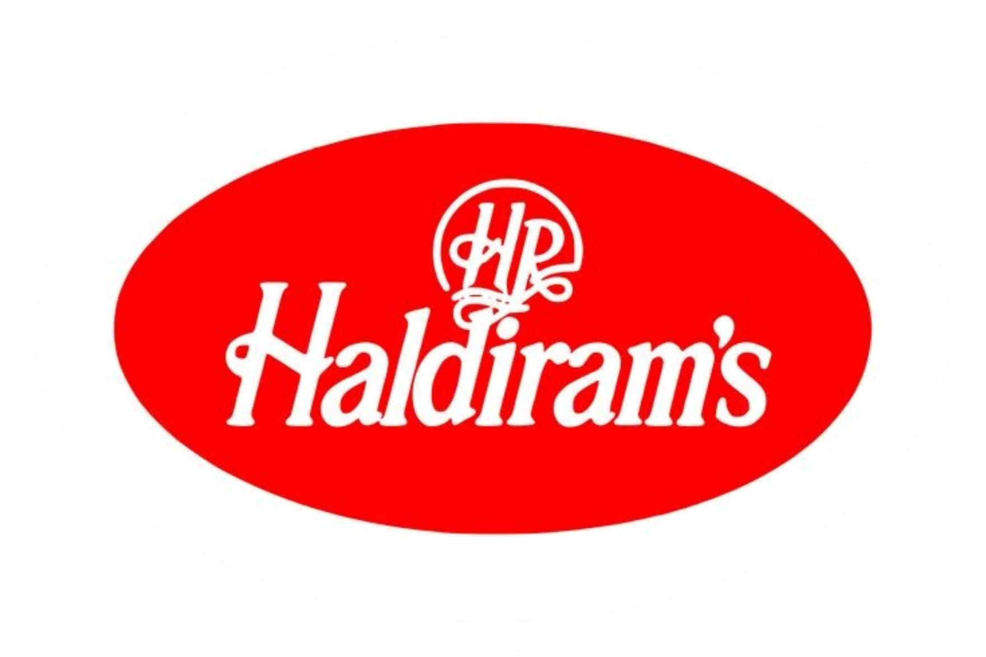

Haldiram Snacks Food Pvt. Ltd., doing business as Haldiram’s is an Indian multinational fast-food restaurant chain, founded in 1937, as a confectionery and desserts shop in Bikaner, Rajasthan, by Ganga Bhishen Agarwal. It is currently based in Noida.

# Comprehensive Digital Marketing foR HALDIRAM’S

Brand Marketing Strategy

1. *Objective*: Increase brand awareness, drive website traffic, and boost online sales.
2. *Target Audience*: Foodies, families, and individuals who appreciate traditional Indian sweets and snacks.
3. *Unique Selling Proposition (USP)*: Emphasize Haldiram’s rich heritage, quality ingredients, and innovative products.
4. *Brand Positioning*: Position Haldiram’s as a premium, trustworthy, and customer-centric brand.

Content Creation

1. *Content Types*:

* Blog posts (recipes, behind-the-scenes, product showcases)
* Social media posts (product promotions, user-generated content, engaging stories)
* Email newsletters (exclusive offers, new product launches, events)
* Video content (product demos, cooking tutorials, brand stories)

1. *Content Calendar*: Plan and schedule content in advance to ensure consistency and efficiency.
2. *Content Distribution*: Share content across social media platforms, email newsletters, and the website.

SEO

1. *Keyword Research*: Identify relevant keywords (e.g., “Indian sweets,” “traditional snacks,” “Haldiram’s products”).
2. *On-Page Optimization*:

* Optimize website structure, meta tags, and content for target keywords.
* Ensure mobile-friendliness, page speed, and secure protocol (HTTPS).

3. *Technical SEO*:

* Set up and manage Google Search Console and Analytics.
* Monitor website crawl errors, sitemap, and robots.txt.

4. *Link Building*: Obtain high-quality backlinks from relevant food blogs, websites, and directories.

*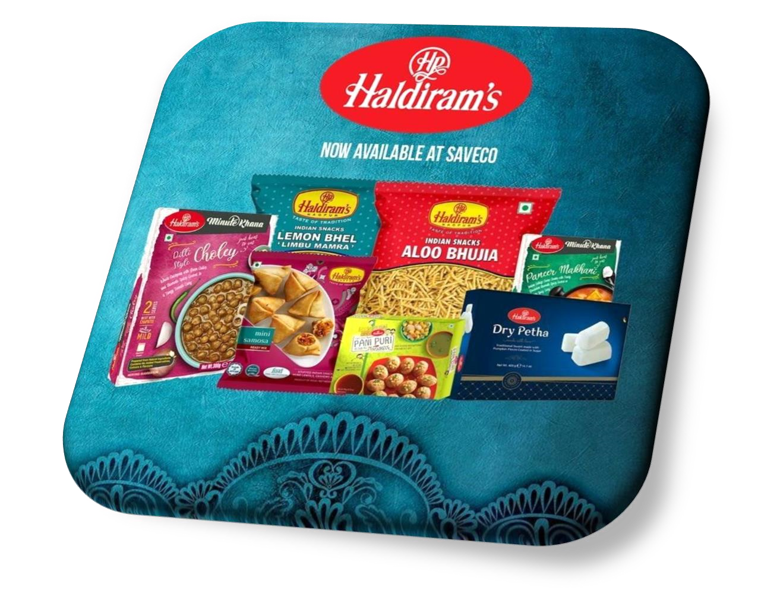

BRAND STUDY, COMPETITOR ANALYSIS

& BUYER’S/AUDIENCE’S PERSoNA

## **Brand Study**

1. *Brand History*: Haldiram’s was founded in 1937 by Ganga Ram Agrawal in Bikaner, Rajasthan, India. The company started as a small shop selling traditional Indian sweets and snacks.
2. *Brand Mission*: Haldiram’s mission is to provide high-quality, traditional Indian sweets and snacks that cater to the diverse tastes and preferences of its customers.
3. *Brand Values*: Haldiram’s values include:
   * Quality: Ensuring the highest quality of ingredients and products.
   * Tradition: Preserving traditional Indian recipes and cooking methods.
   * Innovation: Continuously innovating and introducing new products and flavors.
   * Customer Satisfaction: Providing excellent customer service and ensuring customer satisfaction.
4. *Brand Unique Selling Proposition (USP)*: Haldiram’s USP is its commitment to quality, tradition, and innovation, making it a trusted and preferred brand for traditional Indian sweets and snacks.
5. *Brand Positioning*: Haldiram’s is positioned as a premium brand that offers high-quality, traditional Indian sweets and snacks that cater to the diverse tastes and preferences of its customers.

## **Competitor Analysis**

1. *Competitors*: Some of the key competitors of Haldiram’s include:
   * Bikanervala
   * Nathu’s Sweets
   * Bengali Sweet House
   * Annapurna Sweets
2. *Competitor Strengths*:
   * Bikanervala: Strong brand presence, wide distribution network, and innovative products.
   * Nathu’s Sweets: Traditional recipes, high-quality products, and strong customer loyalty.
3. *Competitor Weaknesses*:
   * Bikanervala: Limited online presence, high prices, and limited product offerings.
   * Nathu’s Sweets: Limited distribution network, limited product innovation, and traditional marketing strategies.
4. *Competitive Advantage*: Haldiram’s competitive advantage lies in its commitment to quality, tradition, and innovation, making it a trusted and preferred brand for traditional Indian sweets and snacks.

**Buyer’s/Audience’s Persona**

1. *Demographics*:
   * Age: 25-50 years
   * Income: Middle to upper-middle class
   * Education: Graduate or postgraduate
   * Occupation: Working professionals, entrepreneurs, or homemakers
2. *Psychographics*:
   * Values tradition and culture
   * Appreciates quality and authenticity
   * Enjoys trying new foods and flavors - Active on social media and online platforms
3. *Pain Points*:
   * Difficulty finding authentic and high-quality traditional Indian sweets and snacks
   * Limited options for online shopping and delivery
   * Concerns about food safety and hygiene
4. *Goals and Aspirations*:
   * To enjoy traditional Indian sweets and snacks that are authentic and high-quality
   * To explore new flavors and products
   * To have a convenient and hassle-free shopping experience
5. *Behavior Patterns*:
   * Regularly shops online and offline for traditional Indian sweets and snacks
   * Actively engages with food brands on social media
   * Reads reviews and ratings before making a purchase

Values recommendations from friends and family

### SEO AND KEYWORD RESEARCH

#### SEO Audit

1. *Website Structure*: Haldiram’s website has a clear and organized structure, with easy navigation and a user-friendly interface.
2. *Page Speed*: The website’s page speed is average, with a score of 60/100 on Google PageSpeed Insights.
3. *Mobile-Friendliness*: The website is mobile-friendly, with a responsive design that adapts to different screen sizes.
4. *Content Quality*: The website’s content is informative and engaging, with a clear focus on traditional Indian sweets and snacks.

#### Keyword Research

1. *Primary Keywords*:
   * “Traditional Indian sweets”

* + “Indian snacks online”
  + “Haldiram’s products”

1. *Secondary Keywords*:
   * “Indian sweets online”
   * “Traditional Indian snacks”
   * “Haldiram’s sweets”
2. *Long-Tail Keywords*:
   * “Traditional Indian sweets online delivery”
   * “Indian snacks for festivals”
   * “Haldiram’s products for gifts”
3. *Keyword Difficulty*: The primary keywords have a moderate to high difficulty level, with a Moz Keyword Difficulty score of 50-70.

#### On-Page Optimization

1. *Title Tags*: Updated title tags to include primary keywords, such as “Traditional Indian Sweets | Haldiram’s”.
2. *Meta Descriptions*: Wrote compelling and informative meta descriptions that include secondary keywords, such as “Indulge in the rich flavors of traditional Indian sweets and snacks from Haldiram’s”.
3. *Header Tags*: Organized content using header tags (H1, H2, H3) to improve structure and readability.
4. *Content Optimization*: Optimized content to include target keywords, with a focus on natural and engaging writing.
5. *Image Optimization*: Optimized images to include target keywords in alt tags and file names.
6. *Mobile-Friendly Content*: Ensured that all content is mobile-friendly and easily accessible on different devices.

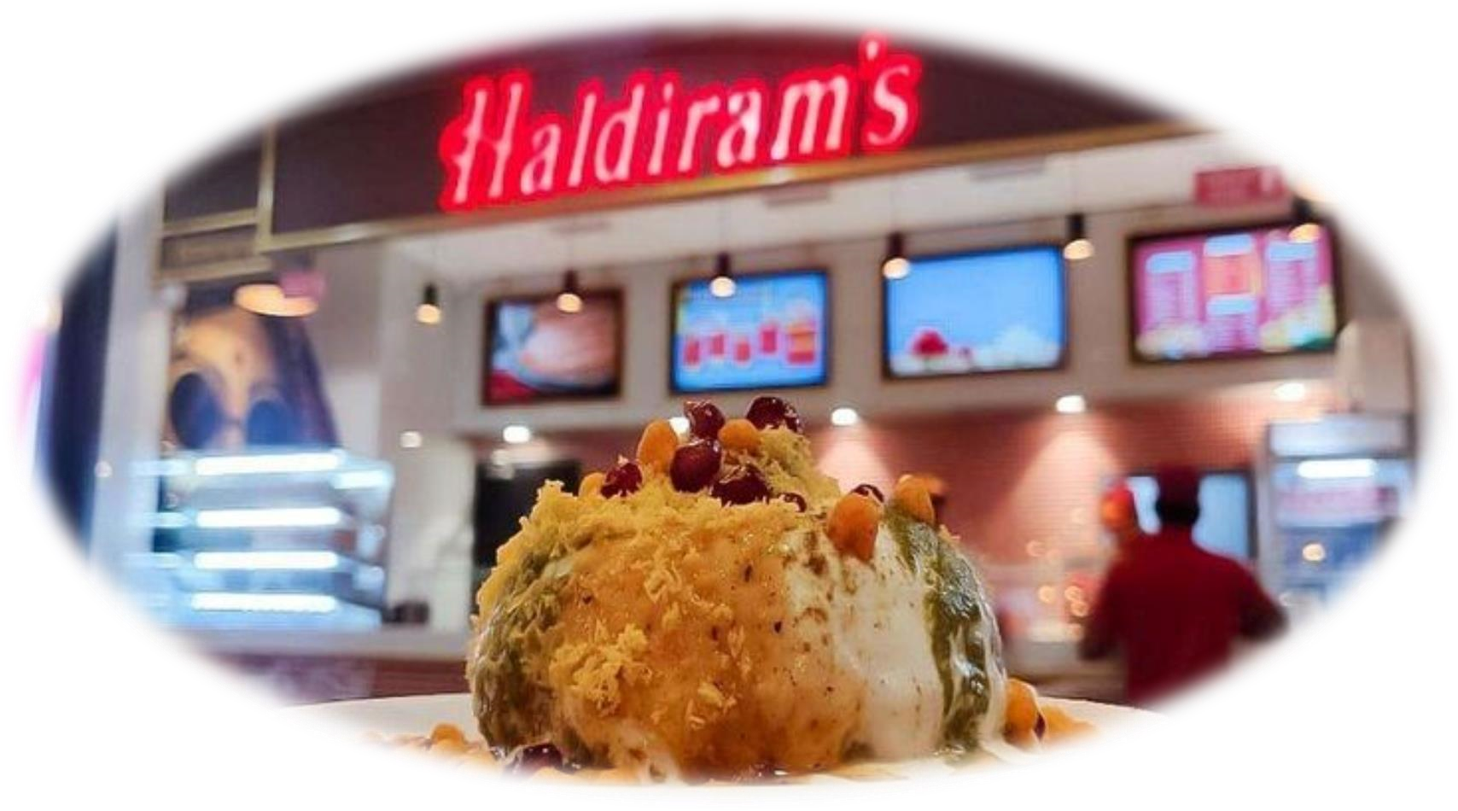

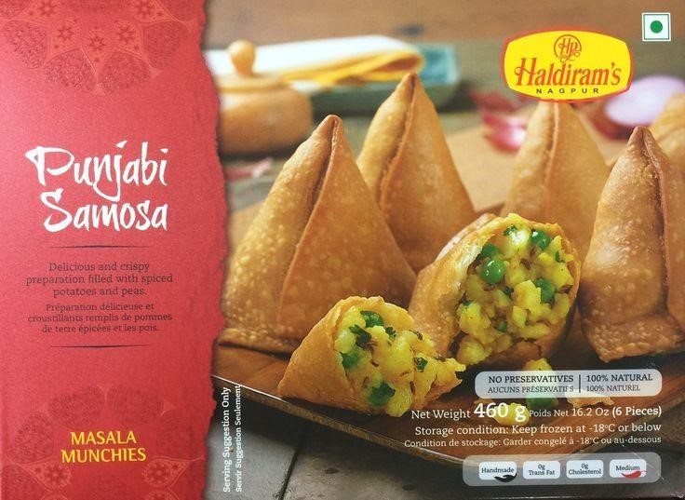

#### CONTENT IDEAS AND MARKETING STRATEGIES

Content Ideas

1. *Recipe Blog Posts*: Share traditional Indian recipes that feature Haldiram’s products, such as sweets and snacks.
2. *Behind-the-Scenes Videos*: Showcase the making of Haldiram’s products, highlighting the quality and care that goes into each item.
3. *Customer Testimonials*: Share stories and reviews from satisfied customers who have enjoyed Haldiram’s products.
4. *Indian Festival Guides*: Create guides and content around Indian festivals, highlighting traditional sweets and snacks that are typically enjoyed during these celebrations.
5. *Product Showcase Videos*: Create short, engaging videos that showcase Haldiram’s products, highlighting their quality, taste, and packaging.
6. *Food and Culture Blog Posts*: Share articles and stories about Indian food, culture, and traditions, highlighting the importance of sweets and snacks in Indian cuisine.
7. *Social Media Challenges*: Launch social media challenges that encourage customers to share their favorite Haldiram’s products, recipes, or moments.

Marketing Strategies

1. *Influencer Marketing*: Partner with social media influencers and bloggers in the food and lifestyle spaces to promote Haldiram’s products.
2. *Email Marketing*: Build an email list and send regular newsletters to subscribers, featuring new products, promotions, and recipes.
3. *Social Media Advertising*: Run targeted social media ads on platforms like Facebook, Instagram, and Twitter to reach new customers and drive sales.
4. *Content Marketing*: Develop a content marketing strategy that includes blog posts, videos, and social media content to attract and engage with target audiences.
5. *Loyalty Program*: Launch a loyalty program that rewards customers for repeat purchases, referrals, and other engagement metrics.
6. *Partnerships and Collaborations*: Partner with other Indian food brands, restaurants, and food delivery services to offer bundled promotions and increase visibility.

###### CONTENT CREATION AND CURATION

Post Creations

1. **\*Blog Posts*: Create informative and engaging blog posts on topics related to traditional Indian sweets and snacks, such as recipes, health benefits, and cultural significance.**
2. **\*Social Media Posts*: Create social media posts that showcase Haldiram’s products, share customer testimonials, and provide updates on new products and promotions.**
3. **\*Product Descriptions*: Write compelling and descriptive product descriptions that highlight the features, benefits, and unique selling points of each product.**

**Designs/Video Editing**

1. **\*Visual Identity*: Develop a visual identity for Haldiram’s that includes a consistent color palette, typography, and imagery.**
2. **\*Product Images*: Create high-quality product images that showcase the products in a lifestyle setting.**
3. **\*Video Content*: Create engaging video content that showcases the products, shares customer testimonials, and provides updates on new products and promotions.**
4. **\*Editing and Post-Production*: Edit and post-produce all video content to ensure it meets the brand’s visual identity and quality standards.**

**Ad Campaigns over Social Media**

1. **\*Target Audience*: Identify the target audience for each ad campaign, including demographics, interests, and behaviors.**
2. **\*Ad Creative*: Develop ad creative that includes eye-catching images, compelling headlines, and clear calls-to-action.**
3. **\*Ad Copy*: Write ad copy that highlights the benefits and unique selling points of each product.**
4. **\*Budget Allocation*: Allocate budget to each ad campaign based on the target audience, ad creative, and ad copy.**

**EMAIL Ideation and Creation**

1. **\*Email Newsletter*: Create a monthly email newsletter that showcases new products, promotions, and events.**
2. **\*Welcome Email*: Create a welcome email that thanks subscribers for joining the mailing list and provides a discount code for their first purchase.**

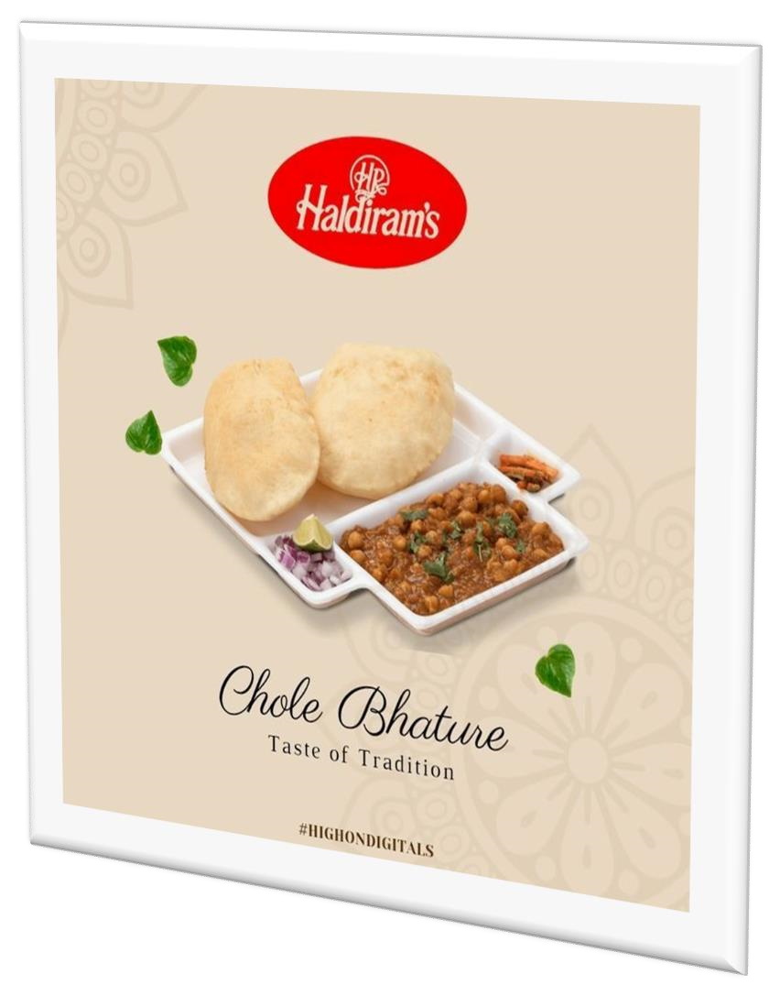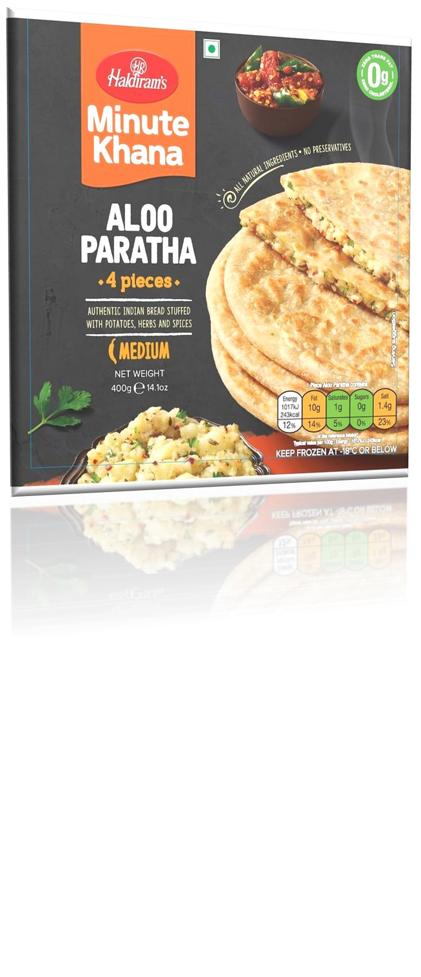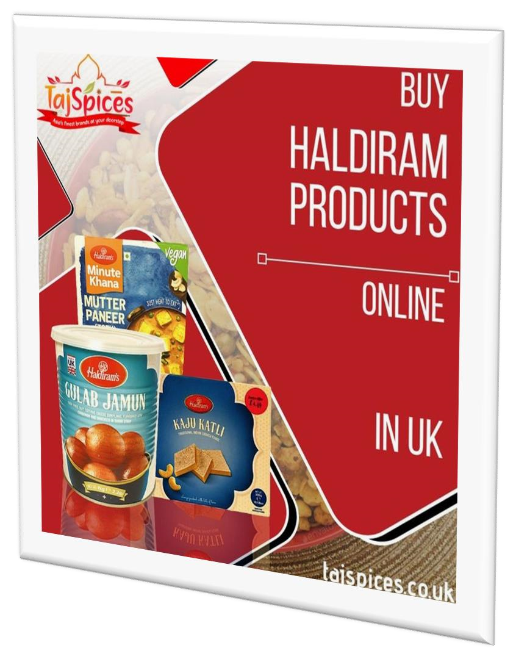

NamE : SHAIK.AMEENA

HALL TICKET : 22231014035

GROUP : B COM COMPUTERS

COLLEGE : VASAVI MAHILA KALASALA

EMAIL : [shaikameena270@gmail.com](mailto:shaikameena270@gmail.com)

University : rayalaseema University

Team id : LTVIP2025TMID21853

Project title : comprehensive digital

marketing for haldiram’s